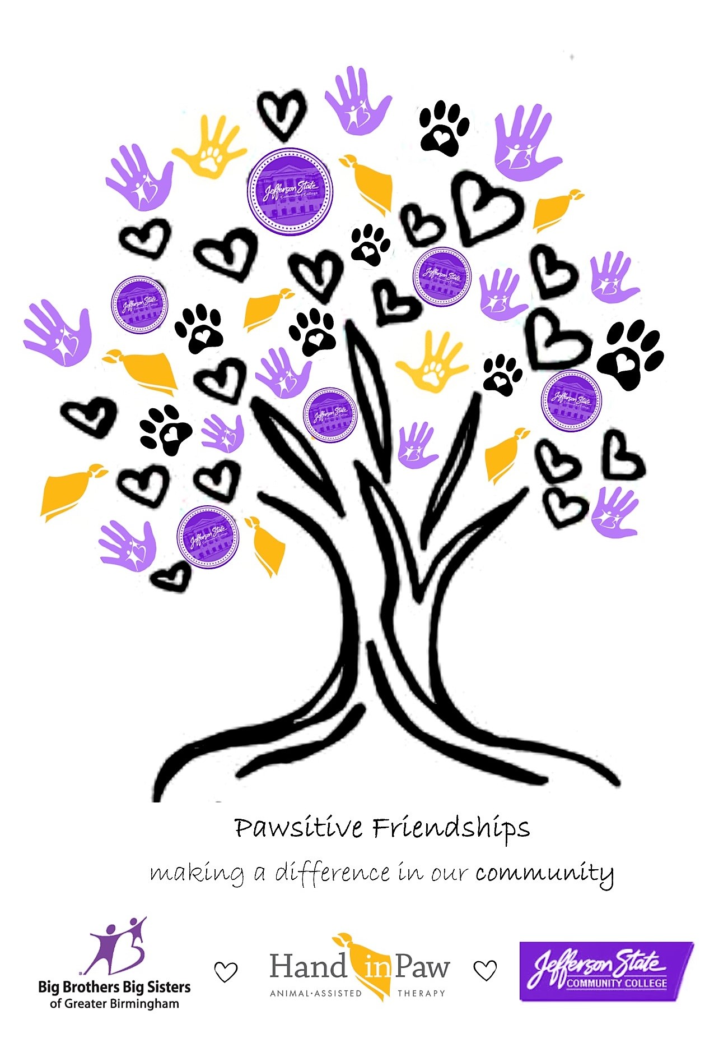

FOR IMMEDIATE RELEASE CONTACT:
April 24th, 2017 Sue Johnson, CEO, Big Brothers Big Sisters of Greater Birmingham
(205) 939-5590 or sjohnson@bbbsbhm.org
Laura Cardwell, Executive Director, Hand in Paw
(205) 322-5144 x151 or laura@handinpaw.org
Damita Hill, Coordinator of Marketing and Community Outreach,
Jefferson State Community College
(205) 856-7884 or dwhill@jeffersonstate.edu

BIG BROTHERS BIG SISTERS OF GREATER BIRMINGHAM, HAND IN PAW, AND JEFFERSON STATE COMMUNITY COLLEGE share PAWSITIVE FRIENDSHIPS

Three organizations to hold tree-planting event to celebrate collaboration

Birmingham, AL: As Arbor Day approaches, we reflect on all that trees symbolize. Seeds, roots, trunks, branches, and blossoms have all inspired countless metaphors. We think of something starting small and – if watered—growing fruitful and strong.

On Thursday, April 27th at 2:15 pm, Big Brothers Big Sisters of Greater Birmingham, Jefferson State Community College, and Hand in Paw will come together on Jeff State’s Jefferson Campus to leave a lasting symbol of the beauty of friendship.

Hand in Paw Executive Director Laura Cardwell said, “Hand in Paw is excited to be a part of Pawsitive Friendships. This event was coordinated with our good friends at Big Brothers Big Sisters of Greater Birmingham and Jefferson State Community College to serve as a positive example of spreading good will. In tribute to Arbor Day, we will come together to plant a dogwood tree as a symbol of love and kindness. Our intention is to continue to nurture this growth of compassion throughout our community.”

70 people will take part in the planting ceremony, including Bigs, Littles, and staff representatives from the three organizations. Four therapy dogs will take part as well.

"For the past three years Jefferson State Community College has partnered with Big Brothers Big Sisters in the Proof Positive Mentoring Program. From our perspective, it has been a huge success. By participating in Pawsitive Friendships, this allows the Jefferson State family to partner with another wonderful community non-profit organization such as Hand in Paw,” says Guin Robinson, Director, Office of Community Outreach at Jefferson State.

While the three organizations have different missions, through collaboration they succeed in making the community a brighter place.

“Big Brothers Big Sisters currently provides mentoring services to Tarrant High School students and Jefferson State Community College through our Proof Positive Mentoring Program. In an effort to expose children to positive role models and encourage them to graduate High School and seek higher education, Big Brothers Big Sisters transports the teens on a regular basis to the Community College campus to meet with their Big Brothers and Big Sisters who are staff working for the college. We are excited that volunteer teams from Hand in Paw will be working with the matches to help them develop empathy, responsibility and anti-bullying values,” says Sue Johnson, CEO of Big Brothers Big Sisters of Greater Birmingham.

Our thanks to Charlie Thigpen’s Garden Gallery for donating the Dogwood tree for this event.

###

ABOUT BIG BROTHERS BIG SISTERS OF GREATER BIRMINGHAM
Big Brothers Big Sisters mission is to provide children facing adversity with strong and enduring, professionally supported 1-to-1 relationships that change their lives for the better, forever. For more information, visit www.bbbsbhm.org

ABOUT JEFFERSON STATE COMMUNITY COLLEGE
For more than 50 years, Jefferson State has led the way in providing excellence in education, value and personal attention. Jefferson State serves approximately 15,000 students each year and is one of the largest community colleges in the state. To learn more, visit www.jeffersonstate.edu

ABOUT HAND IN PAW
With a mission to improve human health and well-being, Hand in Paw is Alabama’s premier Animal-Assisted Therapy provider, with a corps of professionally-trained volunteer handler and animal Therapy Teams serving people in 100 medical centers, schools, and human service organizations. Jefferson State serves approximately 15,000 students each year and is one of the largest community colleges in the state. For more information, visit www.handinpaw.org.

